Data Spice 2.0 Tutorial

Step 1: Go to <https://doomlab.shinyapps.io/dataspice2/> to access Data Spice 2.0

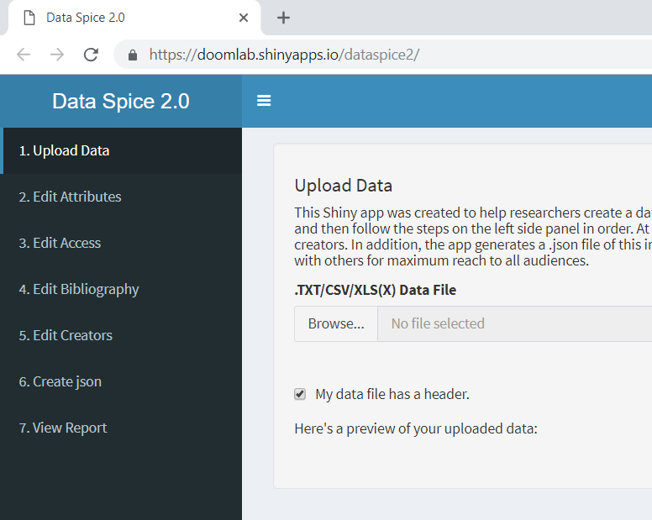

Step 2: Start by uploading a .TXT, .CSV. or XLS data file by clicking browse and selecting the desired file.

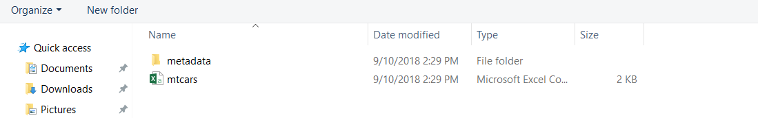

The table will be automatically filled from the data file you selected.

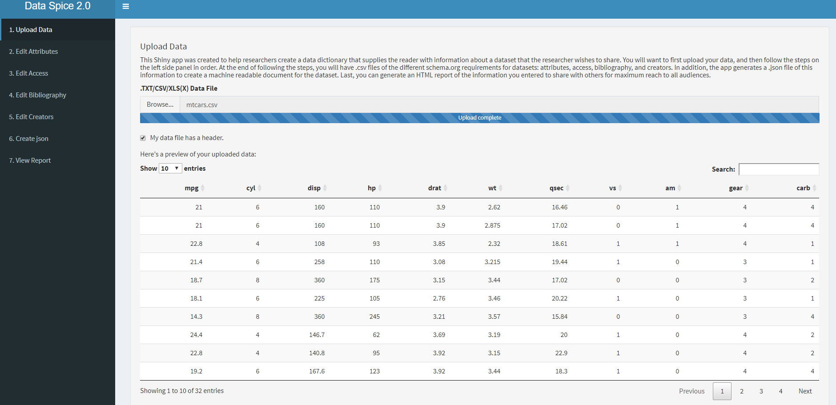

Step 3: Go to the “Edit Attributes” page to add description to the variables provided from the data file.

The data uploaded will be copied into the table on this page.

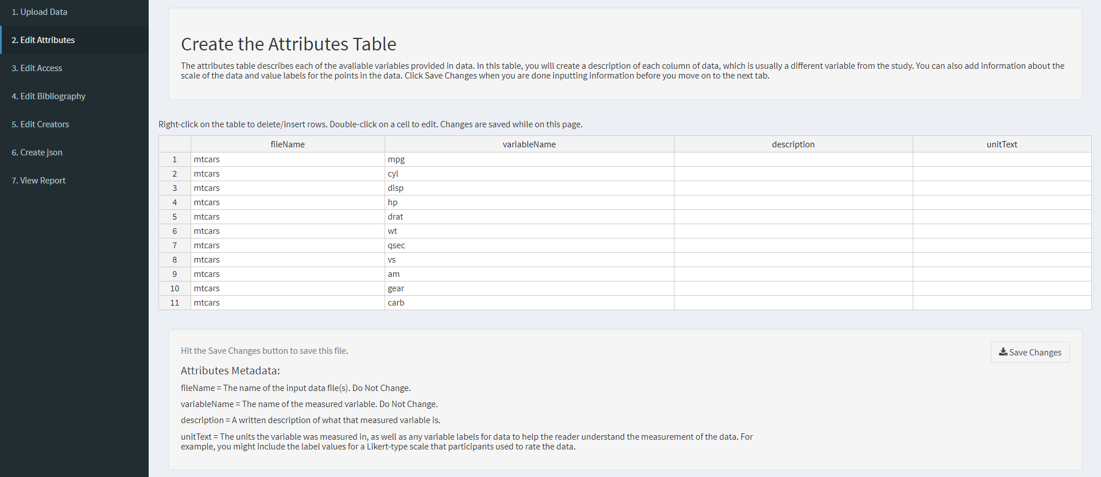

Edit the table by typing directly in it.

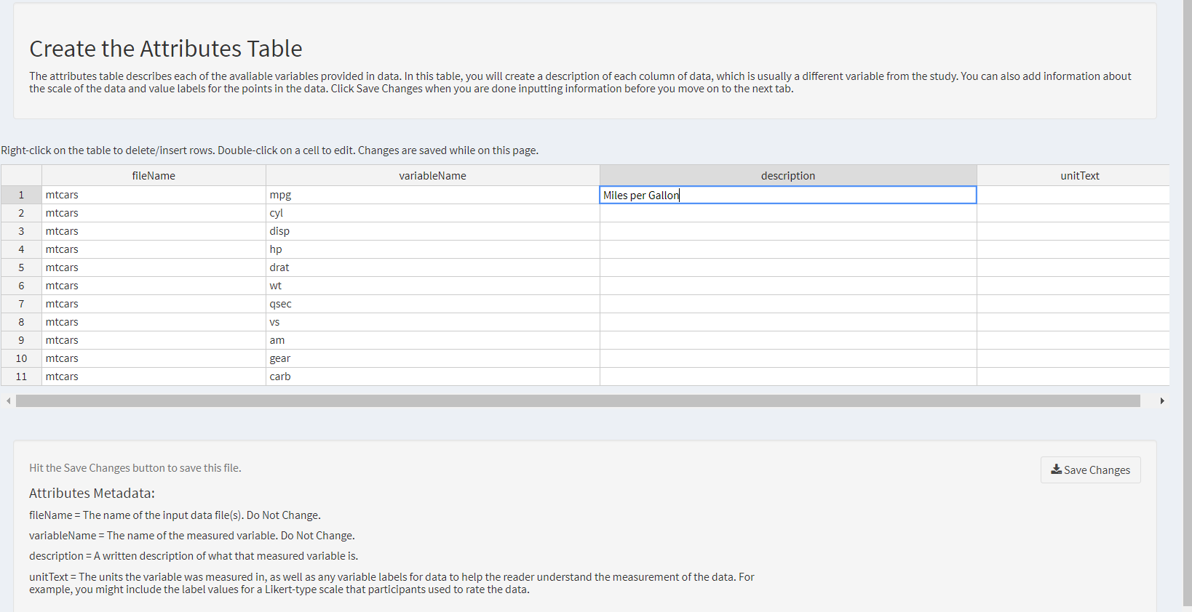

Make sure to hit “Save Changes” to save the table before moving onto the next step.

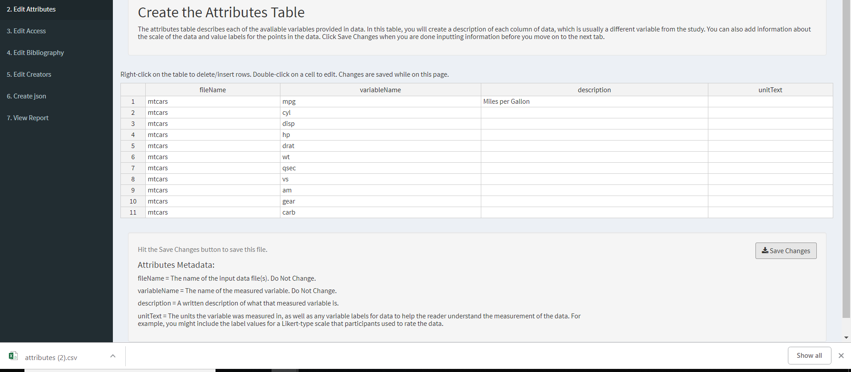

Step 4: Go to the “Edit Access” page to include the name, type, and location of the data file.

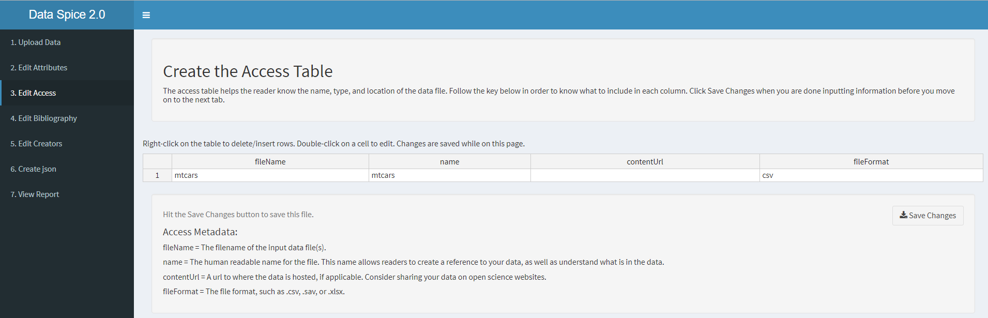

Edit the table by directly typing in the desired box and then hit “Save Changes” before moving on to the next step.

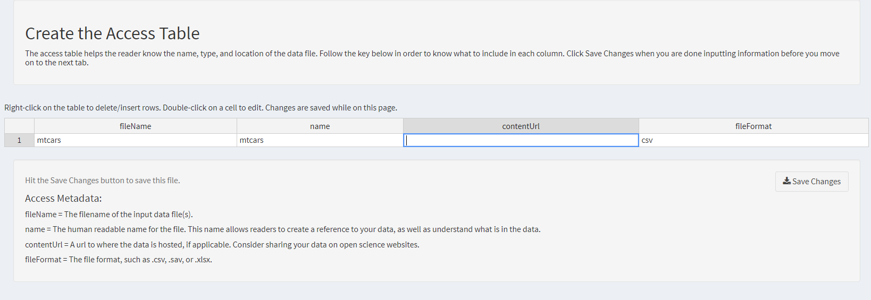

Step 5: Go to the “Edit Bibliography” to include information about the data collection and data citation.

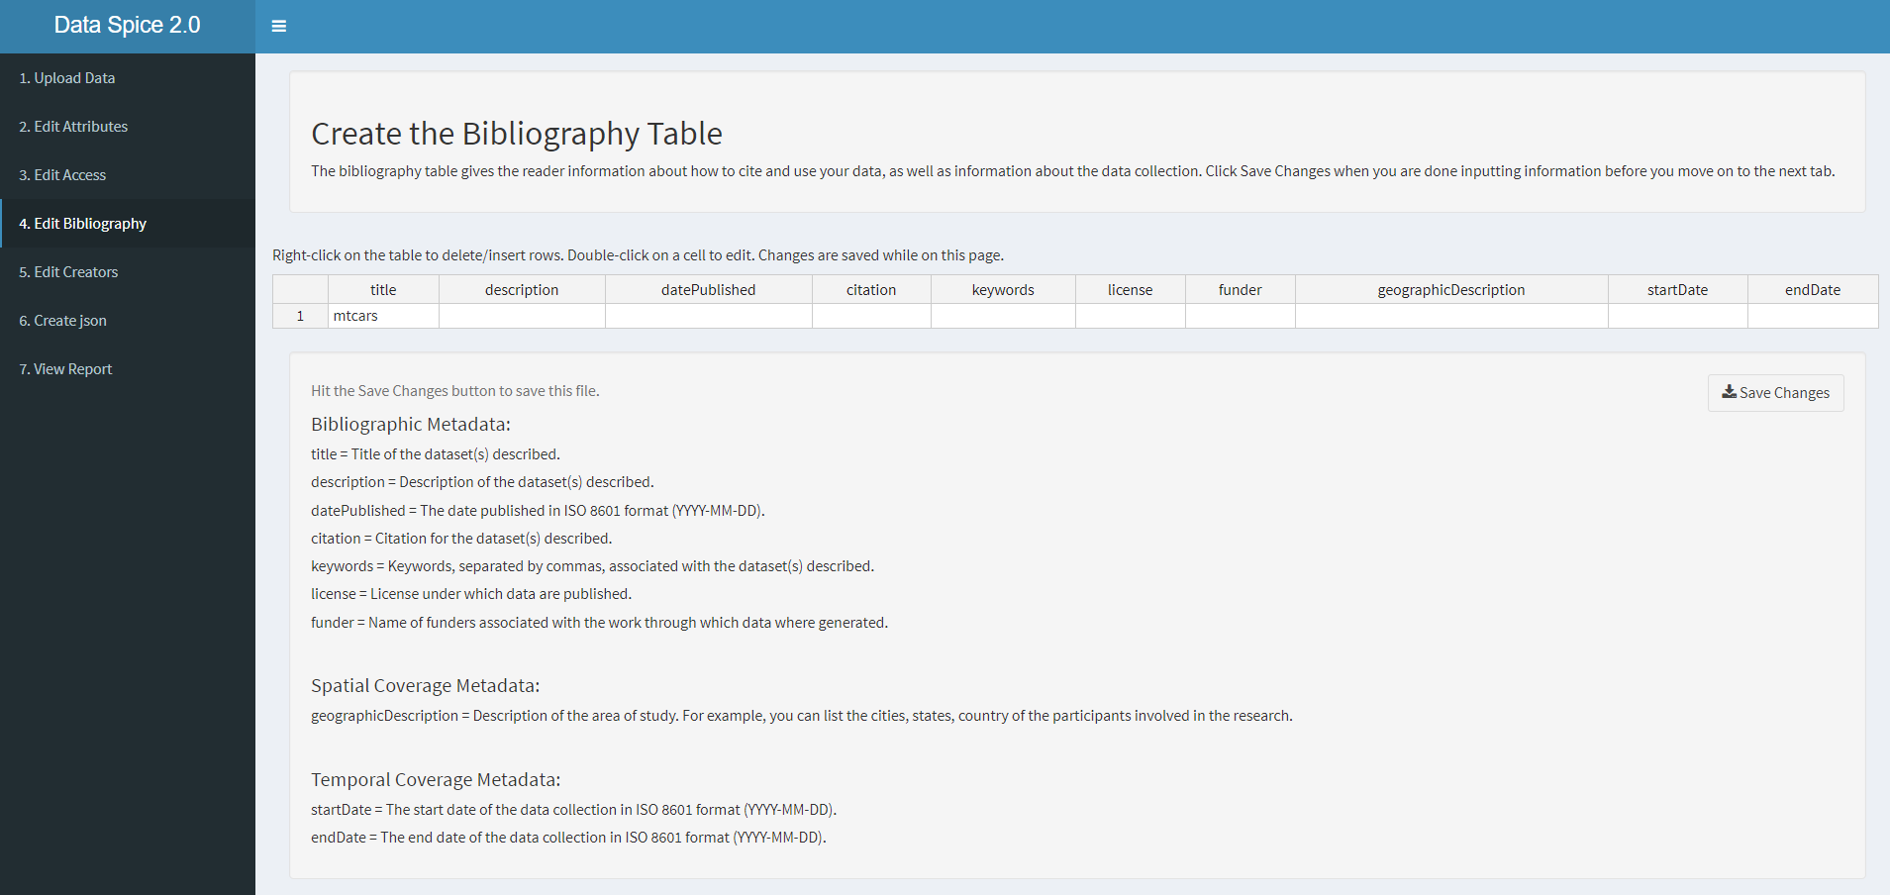

Edit the table by clicking directly on the box and make sure to hit “Save Changes” before moving on to the next step.

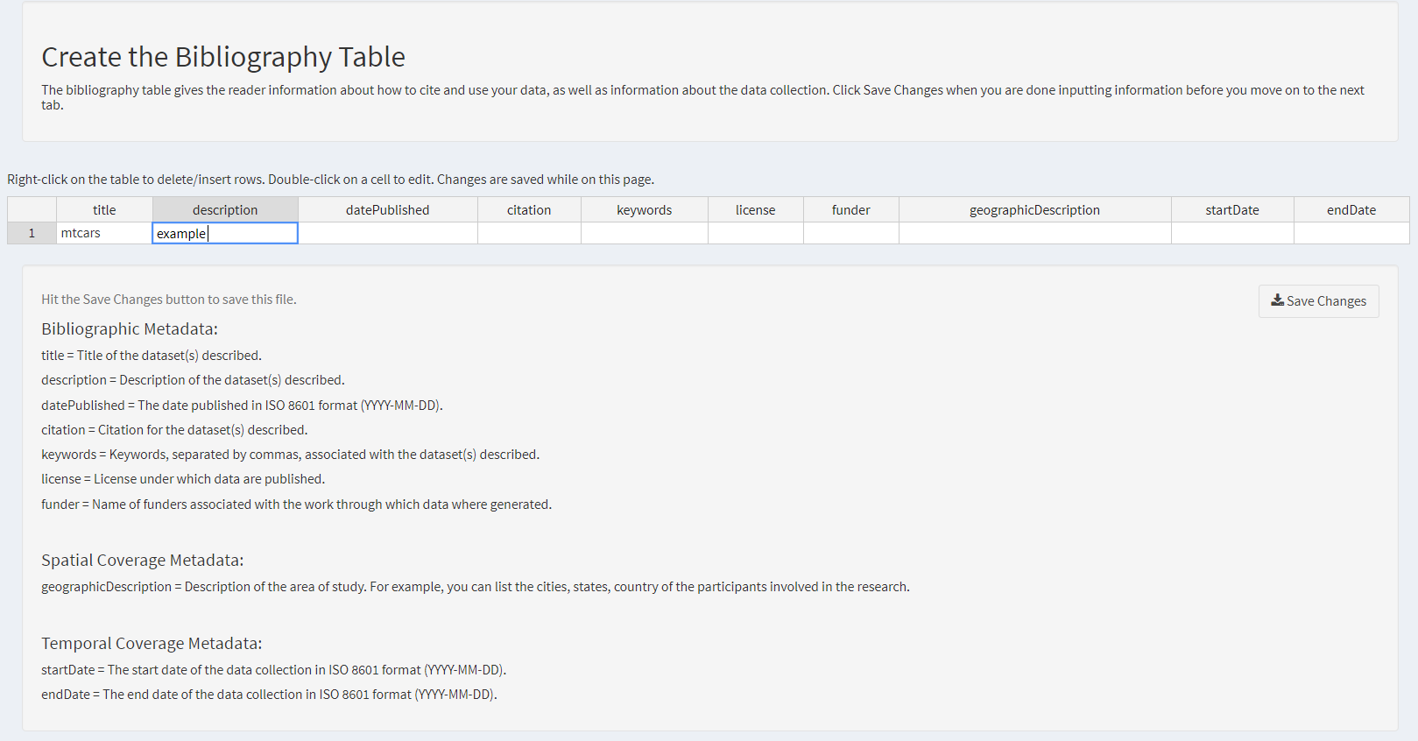

Step 6: Go to the “Edit Creators” page to include citation information about the researchers who were involved in data collection and creation.

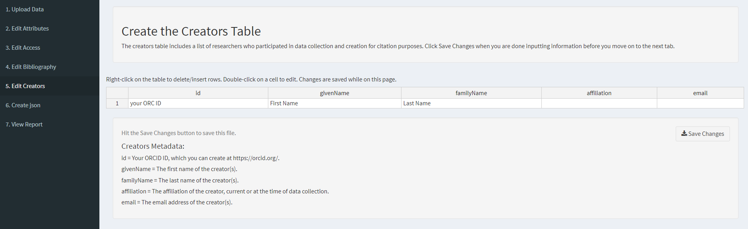

Edi the table by typing directly on it and hit “Save Changes” before moving on to the next step.

Step 7: Go to the “Create json” page to download the .json file of the metadata created by editing the tables from previous pages.

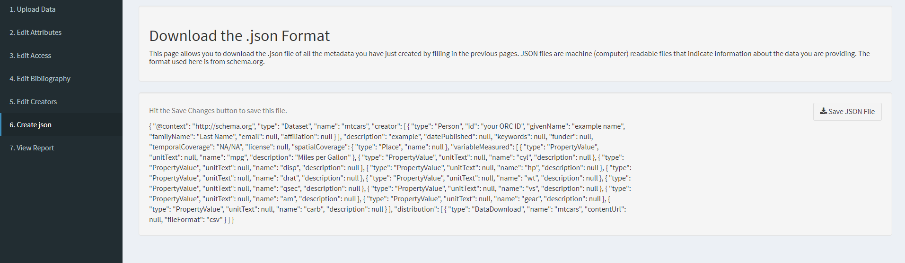

Click “Save JSON File” to save the metadata as a .json file.

Step 8: Go to “View Report” to view the metadata as a HTML report.

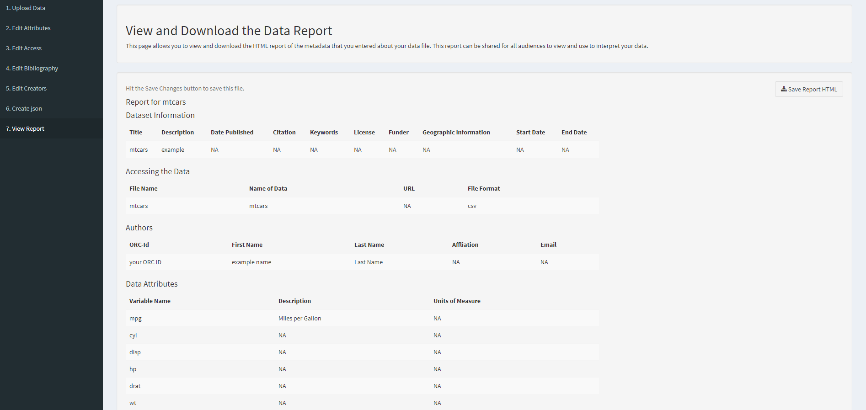

Click “Save Report HTML” to save the report as a HTML file.

Open the file to view the HTML report of the metadata.

